BLOOD SAFETY INDICATOR (BSI)

WEB SITE MANUAL

Approved by:

|  |  |
| --- | --- |
| __________________________________  **Pedrito Y. Tagayuna**  Medical Specialist III,MD,FPSP  Head IMU and NBBNetS | ___________________________________  **Marites B. Estrella**  RN, MM, MDM  Designated Program Manager, NVBSP |

1. **Chrome.pngAccessing the NVBSP web sites**
   1. Open your browser preferably

`Google Chrome` to fully support

the features of the web site

* 1. For **NVBSP** web site, type in

The address bar `*home.nbbnets.net*`

* 1. For **NBBNetS** web site, type in

the address bar

` *www.nbbnets.net`*

* 1. For **National Sandugo Awards**

web site, type in the address

bar `*home.nbbnets.net/sandugo*`

* 1. For **World Blood Donor Day** web

site, type in the address bar

`*wbdd2015palawan.com*`

* 1. For **Blood Safety Indicator** web site,

type in the address bar

`*home.nbbnets.net/bsi*`

* 1. Then click **Enter** on the

keyboard

1. **home page icon.PNGAccessing the Home page**
   1. You can view the content of the home page

clicking the Home icon

* 1. 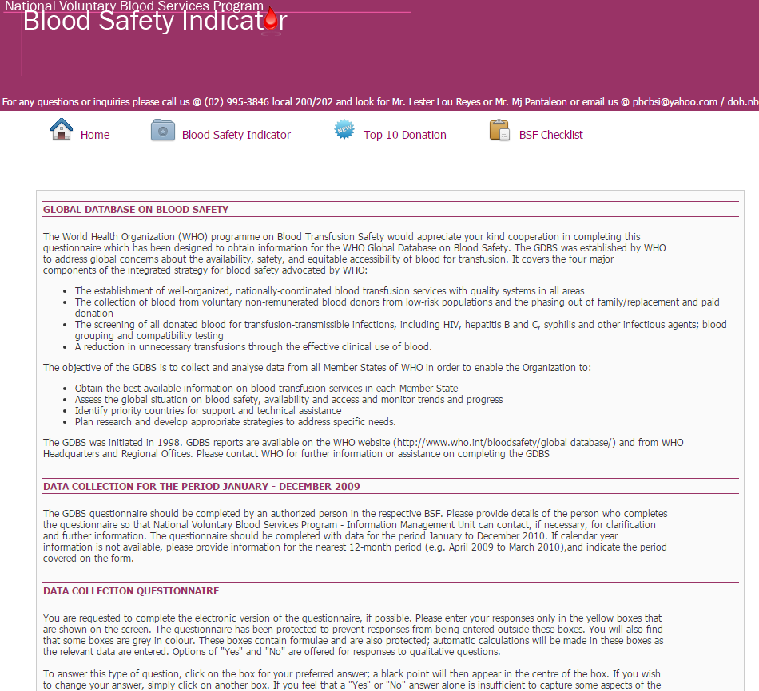The homepage contains

instructions for the following:

* + 1. Global Database on Blood

Safety

* + 1. Data Collection Period
    2. Data collection Questionaire

Instruction

1. **bsi icon.PNGDownloading the Blood Safety Indicator (BSI) worksheet**
   1. you can access the Blood Safety Indicator (BSI)

worksheet by clicking the Blood Safety Indicator

icon

* 1. 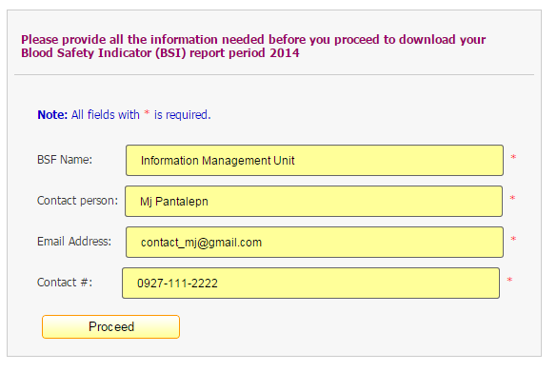to download the Blood Safety Indicator

(BSI) worksheet, provide the

necessary information needed

bsi proceed btn.PNG

* 1. Then click

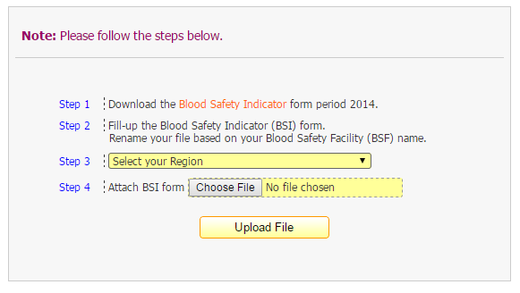

* 1. You will be redirected to this page:

Proceed with

1. Download the Blood Safety Indicator

Worksheet by clicking the Blood Safety

Indicator link in Step 1

* + - 1. Follow Step 2 and Select your Region

in Step 3

* + - 1. Attach your accomplished BSI report

by clicking `*Choose File*` or the ‘*Choose File*’ button

bsi 2nd step btn.PNG

* 1. Then click

bsi 2nd step - success upload.PNG

* 1. If no errors found, then you will see

this prompt message

1. **Accessing Top Ten/(10) Blood Safety Facilities (based on Total Donation)**
   1. top10 link.PNGTo access the Top 10 BSF

(*based on Total Donation*), click the

Top 10 icon

* 1. The user will see a list of Top 10 Blood Safety Facilities (BSF) in their

respective years

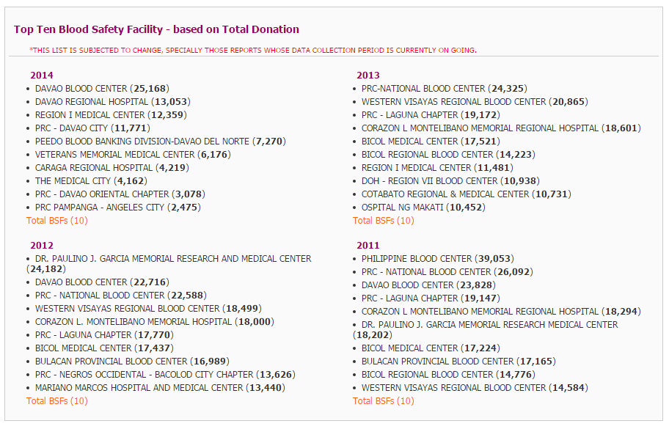

* 1. Note: The list is subjected to change, especially for reports with ongoing data collection

1. **BSF checklist link.PNGBlood Safety Facility(BSF) Checklist**
   1. To access the Blood Safety Facility Checklist,

Click the BSF Checklist icon

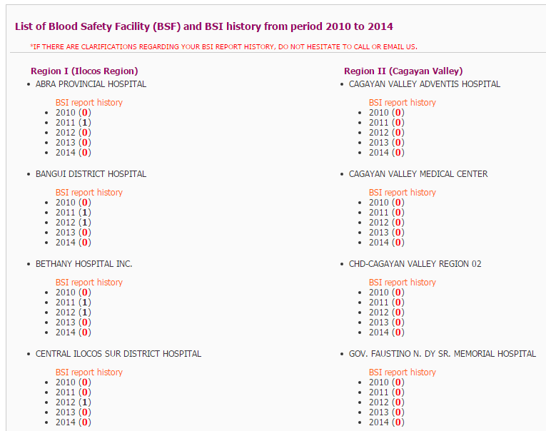

* 1. The list of Blood Service Facility (BSF),

Arranged per Region with their

Corresponding *Blood Safety Indicator*

*(BSI) report history, will appear*

* 1. to view specific Blood Service Facility

BSF checklist Find BSF.PNG(BSF), 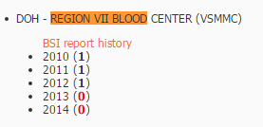Click **Ctrl + F** in the keyboard

A search box will appear

on the upper right corner of

the browser – type the name of the BSF

you like to view

Note: **0** means no BSI Report submitted for that particular year

1 means BSI Report submitted for that particular year